Helping Hand-Digital Donation Platform
For
XPLORA
INNOVATHON-2026

Submitted By
TEAM- 25
Jitendra Kumar Nayak
Prabhupada Panda
Suprit Prasad Nayak
Jyoti Prakash Arukha

Under the Guidance of
RAKESH KUMAR RAY

HOD, CSE

DEPT. OF COMPUTER SCIENCE & ENGINEERING

SCHOOL OF ENGINEERING &TECHNOLOGY, CUTM, ODISHA
FEBRUARY 2025


CENTURION UNIVERSITY OF TECHNOLOGY AND MANAGEMENT, ODISHA SCHOOL OF ENGINEERING AND TECHNOLOGY, BHUBANESWAR CAMPUS
DEPARTMENT OF COMPUTER SCIENCE & ENGINEERING

CERTIFICATE

This is to be certified that the project entitled “Helping Hand-Digital Donation Platform” has been submitted for the Bachelor of Technology in Computer Science Engineering, School of Engineering & Technology, CUTM, BBSR during the academic year 2025-2027 is a persuasive piece of project work carried out by under the guidance of Prof. RAKESH KUMAR RAY and also certified that the above-mentioned project has been duly carried out as per the norm of the college statutes of the university.

Signature of HOD Signature of Project Guide
Prof. RAKESH KUMAR RAY Prof. RAKESH KUMAR RAY

Signature of the External

CENTURION UNIVERSITY OF TECHNOLOGY AND MANAGEMENT, ODISHA SCHOOL OF ENGINEERING AND TECHNOLOGY, BHUBANESWAR CAMPUS
DEPARTMENT OF COMPUTER SCIENCE & ENGINEERING

DECLARATION

We hereby declare that the project entitled “Helping Hand-Digital Donation Platform” Submitted for the “Xplora Innovathon-2026” is our original work and the project has not formed the basis for the award of any Degree / Diploma or any other similar titles in any other University / Institute.

250320100025 | Jitendra Kumar Nayak
250320100060 | Prabhupada Panda
250320100037 | Suprit Prasad Nayak
250320100047 | Jyoti Prakash Arukha

Date:
Place

CENTURION UNIVERSITY OF TECHNOLOGY AND MANAGEMENT, ODISHA SCHOOL OF ENGINEERING AND TECHNOLOGY, BHUBANESWAR CAMPUS
DEPARTMENT OF COMPUTER SCIENCE & ENGINEERING

ACKNOWLEDGEMENT

It is our pleasure to be indebted to various people, who directly or indirectly contributed to the development
of this work and who influenced our thinking, behaviour, and acts during the course of our study.

We express our sincere gratitude to Prof. (Dr.) Sujata Chakravarty, Dean, SOET for providing academic support &opportunities.
We also extend our sincere appreciation to Prof. Rakesh Kumar Roy, HOD who provided his valuable
suggestions and precious time in accomplishing our project work.

We also extend our sincere appreciation to Prof. Rakesh Kumar Ray, Project Guide, who provided his valuable suggestions and precious time in completing our project work.
Lastly, we would like to thank the almighty and our parents for their moral support and friends with whom we shared our day-to-day experiences and received lots of suggestions that improved the quality of our work.

250320100025 | Jitendra Kumar Nayak
250320100060 | Prabhupada Panda
250320100037 | Suprit Prasad Nayak
250320100047 | Jyoti Prakash Arukha

Place:
Date:

ABSTRACT

Helping Hand is a location-based mobile donation platform developed using React Native and Node.js that connects donors and receivers in real time. The application enables users to donate food and clothes by sharing their live location and availability time. Receivers can browse nearby donations, reserve items, and contact donors.
The system uses a PostgreSQL database to securely manage users, donations, and reservations. By integrating GPS tracking and REST APIs, Helping Hand provides a seamless and efficient way to support community welfare.
The platform aims to reduce food and clothing waste while strengthening local community support systems.

TABLE OF CONTENTS
Section | Title | Page No.
1 | Certificate | 2
2 | Declaration | 3
3 | Acknowledgement | 4
4 | Abstract | 5
5 | Table of Contents | 6-7
6 | Introduction | 8
7 | Problem Definition | 8
8 | Objectives | 9
9 | Methodology | 9-10
10 | Implementation | 10-19
11 | Model Training | 20
12 | Testing & Evaluation | 20-38
13 | Results & Analysis | 39
14 | Discussion | 39
15 | Challenges | 40
16 | Output / Screehshots | 40-45
17 | Future Scope | 46
18 | Conclusion | 46
19 | References | 47

- INTRODUCTION

In today’s fast-paced world, surplus food and clothes are often wasted while many people struggle to meet basic needs. Although individuals are willing to donate, there is no simple and immediate way to connect donors with nearby people in need.
Helping Hand is designed as a mobile-first, real-time donation system that bridges this gap. The application allows donors to post donations with live GPS location and availability time. Receivers can find nearby donors through a map interface and reserve items instantly.
The platform leverages modern mobile technologies, secure backend architecture, and intuitive UI/UX design to create a reliable community support ecosystem.
Tagline:
“Together, we make change possible.”

2. PROBLEM DEFINITION
The major problems identified are:
- Lack of real-time connection between donors and receivers.
- Food and clothes wastage due to improper distribution systems.
- Absence of a simple, location-based donation platform.
- No structured reservation system to prevent confusion.
- Poor coordination between donors and beneficiaries.
There is a need for a secure, location-based, and easy-to-use mobile application that enables real-time donation and reservation management.

3. OBJECTIVES

The objectives of Helping Hand are:
- To develop a mobile-based donation platform.
- To connect donors and receivers using live GPS tracking.
- To implement a reservation system to avoid duplication.
- To ensure secure authentication and data management.
- To provide a clean and user-friendly interface.
- To build a scalable backend architecture.
- To encourage community participation and reduce waste.

4. METHODOLOGY

The project follows a structured development methodology:
Step 1: Requirement Analysis
- Identified core features (Donate, Receive, Reserve).
- Defined user roles (Donor, Receiver).
- Designed system workflow.
Step 2: System Design
- Created database schema.
- Designed API structure.
- Planned navigation flow.
- Designed UI mockups.
Step 3: Development
- Frontend built using React Native (Expo).
- Backend developed using Node.js and Express.

- Database designed using PostgreSQL with Drizzle ORM.
Step 4: Integration
- Connected frontend with REST APIs.
- Integrated GPS location services.
- Implemented reservation logic.
Step 5: Testing
- Tested authentication.
- Verified database operations.
- Checked reservation flow.
- Performed UI responsiveness testing.

5. IMPLEMENTATION

Frontend Implementation
- React Native with Expo Router for navigation.
- Map integration using Expo Location and Google Maps API.
- State management using React Context and React Query.
- Gradient backgrounds and rounded UI components.
Backend Implementation
- Express.js server with TypeScript.
- RESTful APIs for authentication and donations.
- Session-based authentication using Express Session.
- Input validation using Zod.

import express from "express";
import type { Request, Response, NextFunction } from "express";
import { registerRoutes } from "./routes";
import * as fs from "fs";
import * as path from "path";

const app = express();
const log = console.log;

declare module "http" {
interface IncomingMessage {
rawBody: unknown;
}
}

function setupCors(app: express.Application) {
app.use((req, res, next) => {
const origins = new Set<string>();

if (process.env.REPLIT_DEV_DOMAIN) {
origins.add(`https://${process.env.REPLIT_DEV_DOMAIN}`);
}

if (process.env.REPLIT_DOMAINS) {
process.env.REPLIT_DOMAINS.split(",").forEach((d) => {
origins.add(`https://${d.trim()}`);
});
}

const origin = req.header("origin");

// Allow localhost origins for Expo web development (any port)
const isLocalhost =
origin?.startsWith("http://localhost:") ||
origin?.startsWith("http://127.0.0.1:");

if (origin && (origins.has(origin) || isLocalhost)) {
res.header("Access-Control-Allow-Origin", origin);
res.header(
"Access-Control-Allow-Methods",
"GET, POST, PUT, DELETE, OPTIONS",
);
res.header("Access-Control-Allow-Headers", "Content-Type");
res.header("Access-Control-Allow-Credentials", "true");
}

if (req.method === "OPTIONS") {
return res.sendStatus(200);
}

next();
});
}

function setupBodyParsing(app: express.Application) {
app.use(
express.json({
verify: (req, _res, buf) => {
req.rawBody = buf;
},
}),
);

app.use(express.urlencoded({ extended: false }));
}

function setupRequestLogging(app: express.Application) {
app.use((req, res, next) => {
const start = Date.now();
const path = req.path;
let capturedJsonResponse: Record<string, unknown> | undefined = undefined;

const originalResJson = res.json;
res.json = function (bodyJson, ...args) {
capturedJsonResponse = bodyJson;
return originalResJson.apply(res, [bodyJson, ...args]);
};

res.on("finish", () => {
if (!path.startsWith("/api")) return;

const duration = Date.now() - start;

let logLine = `${req.method} ${path} ${res.statusCode} in ${duration}ms`;
if (capturedJsonResponse) {
logLine += ` :: ${JSON.stringify(capturedJsonResponse)}`;
}

if (logLine.length > 80) {
logLine = logLine.slice(0, 79) + "…";
}

log(logLine);
});

next();
});
}

function getAppName(): string {
try {
const appJsonPath = path.resolve(process.cwd(), "app.json");
const appJsonContent = fs.readFileSync(appJsonPath, "utf-8");
const appJson = JSON.parse(appJsonContent);
return appJson.expo?.name || "App Landing Page";
} catch {
return "App Landing Page";
}
}

function serveExpoManifest(platform: string, res: Response) {
const manifestPath = path.resolve(
process.cwd(),
"static-build",
platform,
"manifest.json",
);

if (!fs.existsSync(manifestPath)) {
return res
.status(404)
.json({ error: `Manifest not found for platform: ${platform}` });
}

res.setHeader("expo-protocol-version", "1");
res.setHeader("expo-sfv-version", "0");
res.setHeader("content-type", "application/json");

const manifest = fs.readFileSync(manifestPath, "utf-8");
res.send(manifest);
}

function serveLandingPage({
req,
res,
landingPageTemplate,
appName,
}: {
req: Request;
res: Response;
landingPageTemplate: string;
appName: string;
}) {
const forwardedProto = req.header("x-forwarded-proto");
const protocol = forwardedProto || req.protocol || "https";
const forwardedHost = req.header("x-forwarded-host");
const host = forwardedHost || req.get("host");
const baseUrl = `${protocol}://${host}`;
const expsUrl = `${host}`;

log(`baseUrl`, baseUrl);
log(`expsUrl`, expsUrl);

const html = landingPageTemplate
.replace(/BASE_URL_PLACEHOLDER/g, baseUrl)
.replace(/EXPS_URL_PLACEHOLDER/g, expsUrl)
.replace(/APP_NAME_PLACEHOLDER/g, appName);

res.setHeader("Content-Type", "text/html; charset=utf-8");
res.status(200).send(html);
}

function configureExpoAndLanding(app: express.Application) {
const templatePath = path.resolve(
process.cwd(),
"server",
"templates",
"landing-page.html",
);
const landingPageTemplate = fs.readFileSync(templatePath, "utf-8");
const appName = getAppName();

log("Serving static Expo files with dynamic manifest routing");

app.use((req: Request, res: Response, next: NextFunction) => {
if (req.path.startsWith("/api")) {
return next();
}

if (req.path !== "/" && req.path !== "/manifest") {
return next();
}

const platform = req.header("expo-platform");
if (platform && (platform === "ios" || platform === "android")) {
return serveExpoManifest(platform, res);
}

if (req.path === "/") {
return serveLandingPage({
req,
res,
landingPageTemplate,
appName,
});
}

next();
});

app.use("/assets", express.static(path.resolve(process.cwd(), "assets")));
app.use(express.static(path.resolve(process.cwd(), "static-build")));

log("Expo routing: Checking expo-platform header on / and /manifest");
}

function setupErrorHandler(app: express.Application) {
app.use((err: unknown, _req: Request, res: Response, next: NextFunction) => {
const error = err as {
status?: number;
statusCode?: number;
message?: string;
};

const status = error.status || error.statusCode || 500;
const message = error.message || "Internal Server Error";

console.error("Internal Server Error:", err);

if (res.headersSent) {
return next(err);
}

return res.status(status).json({ message });
});
}

(async () => {
setupCors(app);
setupBodyParsing(app);
setupRequestLogging(app);

configureExpoAndLanding(app);

const server = await registerRoutes(app);

setupErrorHandler(app);

const port = parseInt(process.env.PORT || "5000", 10);
server.listen(
{
port,
host: "0.0.0.0",
reusePort: true,
},
() => {
log(`express server serving on port ${port}`);
},
);
})();

Database Implementation
Tables:
- Users
- Donations
- Reservations
ORM:
- Drizzle ORM for database interaction.
Security:
- Password hashing using bcrypt.
- Protected routes.
- CORS configuration.

6. MODEL TRAINING

This project does not include machine learning or AI model training.
However, in future versions, machine learning could be implemented for:
- Smart donation recommendations.
- Fraud detection.
- Donation demand prediction.
- User behavior analysis.
Currently, the system operates using rule-based logic and structured database operations.

7. TESTING & EVALUATION

The system was tested under the following scenarios:
1. Authentication Testing
- Valid and invalid login attempts.
- Password hashing verification.
- Session persistence testing.
2. Donation Testing
- Creating donation entries.
- Editing availability time.
- Map marker display accuracy.
3. Reservation Testing
- Successful reservation creation.
- Status update from “Available” to “Reserved”.
- Prevention of duplicate reservation.
4. UI Testing
- Responsiveness on different screen sizes.
- Navigation flow validation.
- Form validation checks.

const fs = require("fs");
const path = require("path");
const { spawn } = require("child_process");
const { Readable } = require("stream");
const { pipeline } = require("stream/promises");

let metroProcess = null;

function exitWithError(message) {
console.error(message);
if (metroProcess) {
metroProcess.kill();
}
process.exit(1);
}

function setupSignalHandlers() {
const cleanup = () => {
if (metroProcess) {
console.log("Cleaning up Metro process...");
metroProcess.kill();
}
process.exit(0);
};

process.on("SIGINT", cleanup);
process.on("SIGTERM", cleanup);
process.on("SIGHUP", cleanup);
}

function stripProtocol(domain) {
let urlString = domain.trim();

if (!/^https?:\/\//i.test(urlString)) {
urlString = `https://${urlString}`;
}

return new URL(urlString).host;
}

function getDeploymentDomain() {
// Check Replit deployment environment variables first
if (process.env.REPLIT_INTERNAL_APP_DOMAIN) {
return stripProtocol(process.env.REPLIT_INTERNAL_APP_DOMAIN);
}

if (process.env.REPLIT_DEV_DOMAIN) {
return stripProtocol(process.env.REPLIT_DEV_DOMAIN);
}

if (process.env.EXPO_PUBLIC_DOMAIN) {
return stripProtocol(process.env.EXPO_PUBLIC_DOMAIN);
}

console.error(
"ERROR: No deployment domain found. Set REPLIT_INTERNAL_APP_DOMAIN, REPLIT_DEV_DOMAIN, or EXPO_PUBLIC_DOMAIN",
);
process.exit(1);
}

function prepareDirectories(timestamp) {
console.log("Preparing build directories...");

if (fs.existsSync("static-build")) {
fs.rmSync("static-build", { recursive: true });
}

const dirs = [
path.join("static-build", timestamp, "_expo", "static", "js", "ios"),
path.join("static-build", timestamp, "_expo", "static", "js", "android"),
path.join("static-build", "ios"),
path.join("static-build", "android"),
];

for (const dir of dirs) {
fs.mkdirSync(dir, { recursive: true });
}

console.log("Build:", timestamp);
}

function clearMetroCache() {
console.log("Clearing Metro cache...");

const cacheDirs = [
...fs.globSync(".metro-cache"),
...fs.globSync("node_modules/.cache/metro"),
];

for (const dir of cacheDirs) {
fs.rmSync(dir, { recursive: true, force: true });
}

console.log("Cache cleared");
}

async function checkMetroHealth() {
try {
const response = await fetch("http://localhost:8081/status", {
signal: AbortSignal.timeout(5000),
});
return response.ok;
} catch {
return false;
}
}

async function startMetro(expoPublicDomain) {
const isRunning = await checkMetroHealth();
if (isRunning) {
console.log("Metro already running");
return;
}

console.log("Starting Metro...");
console.log(`Setting EXPO_PUBLIC_DOMAIN=${expoPublicDomain}`);
const env = {
...process.env,
EXPO_PUBLIC_DOMAIN: expoPublicDomain,
};
metroProcess = spawn("npm", ["run", "expo:start:static:build"], {
stdio: ["ignore", "pipe", "pipe"],
detached: false,
env,
});

if (metroProcess.stdout) {
metroProcess.stdout.on("data", (data) => {
const output = data.toString().trim();
if (output) console.log(`[Metro] ${output}`);
});
}
if (metroProcess.stderr) {
metroProcess.stderr.on("data", (data) => {
const output = data.toString().trim();
if (output) console.error(`[Metro Error] ${output}`);
});
}

for (let i = 0; i < 60; i++) {
await new Promise((resolve) => setTimeout(resolve, 1000));

const healthy = await checkMetroHealth();
if (healthy) {
console.log("Metro ready");
return;
}
}

console.error("Metro timeout");
process.exit(1);
}

async function downloadFile(url, outputPath) {
const controller = new AbortController();
const fiveMinMS = 5 * 60 * 1_000;
const timeoutId = setTimeout(() => controller.abort(), fiveMinMS);

try {
console.log(`Downloading: ${url}`);
const response = await fetch(url, { signal: controller.signal });

if (!response.ok) {
throw new Error(`HTTP ${response.status}`);
}

const file = fs.createWriteStream(outputPath);
await pipeline(Readable.fromWeb(response.body), file);

const fileSize = fs.statSync(outputPath).size;

if (fileSize === 0) {
fs.unlinkSync(outputPath);
throw new Error("Downloaded file is empty");
}
} catch (error) {
if (fs.existsSync(outputPath)) {
fs.unlinkSync(outputPath);
}

if (error.name === "AbortError") {
throw new Error(`Download timeout after 5m: ${url}`);
}
throw error;
} finally {
clearTimeout(timeoutId);
}
}

async function downloadBundle(platform, timestamp) {
// For expo-router apps, the entry is node_modules/expo-router/entry
const url = new URL("http://localhost:8081/node_modules/expo-router/entry.bundle");
url.searchParams.set("platform", platform);
url.searchParams.set("dev", "false");
url.searchParams.set("hot", "false");
url.searchParams.set("lazy", "false");
url.searchParams.set("minify", "true");

const output = path.join(
"static-build",
timestamp,
"_expo",
"static",
"js",
platform,
"bundle.js",
);

console.log(`Fetching ${platform} bundle...`);
await downloadFile(url.toString(), output);
console.log(`${platform} bundle ready`);
}

async function downloadManifest(platform) {
const controller = new AbortController();
const timeoutId = setTimeout(() => controller.abort(), 300_000);

try {
console.log(`Fetching ${platform} manifest...`);
const response = await fetch("http://localhost:8081/manifest", {
headers: { "expo-platform": platform },
signal: controller.signal,
});

if (!response.ok) {
throw new Error(`HTTP ${response.status}`);
}

const manifest = await response.json();
console.log(`${platform} manifest ready`);
return manifest;
} catch (error) {
if (error.name === "AbortError") {
throw new Error(
`Manifest download timeout after 5m for platform: ${platform}`,
);
}
throw error;
} finally {
clearTimeout(timeoutId);
}
}

async function downloadBundlesAndManifests(timestamp) {
console.log("Downloading bundles and manifests...");
console.log("This may take several minutes for production builds...");

try {
const results = await Promise.allSettled([
downloadBundle("ios", timestamp),
downloadBundle("android", timestamp),
downloadManifest("ios"),
downloadManifest("android"),
]);

const failures = results
.map((result, index) => ({ result, index }))
.filter(({ result }) => result.status === "rejected");

if (failures.length > 0) {
const errorMessages = failures.map(({ result, index }) => {
const names = [
"iOS bundle",
"Android bundle",
"iOS manifest",
"Android manifest",
];
return ` - ${names[index]}: ${result.reason?.message || result.reason}`;
});

exitWithError(`Download failed:\n${errorMessages.join("\n")}`);
}

const iosManifest =
results[2].status === "fulfilled" ? results[2].value : null;
const androidManifest =
results[3].status === "fulfilled" ? results[3].value : null;

console.log("All downloads completed successfully");
return { ios: iosManifest, android: androidManifest };
} catch (error) {
exitWithError(`Unexpected download error: ${error.message}`);
}
}

function extractAssets(timestamp) {
const bundles = {
ios: fs.readFileSync(
path.join(
"static-build",
timestamp,
"_expo",
"static",
"js",
"ios",
"bundle.js",
),
"utf-8",
),
android: fs.readFileSync(
path.join(
"static-build",
timestamp,
"_expo",
"static",
"js",
"android",
"bundle.js",
),
"utf-8",
),
};

const assetsMap = new Map();
const assetPattern =
/httpServerLocation:"([^"]+)"[^}]*hash:"([^"]+)"[^}]*name:"([^"]+)"[^}]*type:"([^"]+)"/g;

const extractFromBundle = (bundle, platform) => {
for (const match of bundle.matchAll(assetPattern)) {
const originalPath = match[1];
const filename = match[3] + "." + match[4];

const tempUrl = new URL(`http://localhost:8081${originalPath}`);
const unstablePath = tempUrl.searchParams.get("unstable_path");

if (!unstablePath) {
throw new Error(`Asset missing unstable_path: ${originalPath}`);
}

const decodedPath = decodeURIComponent(unstablePath);
const key = path.posix.join(decodedPath, filename);

if (!assetsMap.has(key)) {
const asset = {
url: path.posix.join("/", decodedPath, filename),
originalPath: originalPath,
filename: filename,
relativePath: decodedPath,
hash: match[2],
platforms: new Set(),
};

assetsMap.set(key, asset);
}
assetsMap.get(key).platforms.add(platform);
}
};

extractFromBundle(bundles.ios, "ios");
extractFromBundle(bundles.android, "android");

return Array.from(assetsMap.values());
}

async function downloadAssets(assets, timestamp) {
if (assets.length === 0) {
return 0;
}

console.log("Downloading assets...");
let successCount = 0;
const failures = [];

const downloadPromises = assets.map(async (asset) => {
const platform = Array.from(asset.platforms)[0];

const tempUrl = new URL(`http://localhost:8081${asset.originalPath}`);
const unstablePath = tempUrl.searchParams.get("unstable_path");

if (!unstablePath) {
throw new Error(`Asset missing unstable_path: ${asset.originalPath}`);
}

const decodedPath = decodeURIComponent(unstablePath);
const metroUrl = new URL(
`http://localhost:8081${path.posix.join("/assets", decodedPath, asset.filename)}`,
);
metroUrl.searchParams.set("platform", platform);
metroUrl.searchParams.set("hash", asset.hash);

const outputDir = path.join(
"static-build",
timestamp,
"_expo",
"static",
"js",
asset.relativePath,
);
fs.mkdirSync(outputDir, { recursive: true });
const output = path.join(outputDir, asset.filename);

try {
await downloadFile(metroUrl.toString(), output);
successCount++;
} catch (error) {
failures.push({
filename: asset.filename,
error: error.message,
url: metroUrl.toString(),
});
}
});

await Promise.all(downloadPromises);

if (failures.length > 0) {
const errorMsg =
`Failed to download ${failures.length} asset(s):\n` +
failures
.map((f) => ` - ${f.filename}: ${f.error} (${f.url})`)
.join("\n");
exitWithError(errorMsg);
}

console.log(`Downloaded ${successCount} assets`);
return successCount;
}

function updateBundleUrls(timestamp, baseUrl) {
const updateForPlatform = (platform) => {
const bundlePath = path.join(
"static-build",
timestamp,
"_expo",
"static",
"js",
platform,
"bundle.js",
);
let bundle = fs.readFileSync(bundlePath, "utf-8");

bundle = bundle.replace(
/httpServerLocation:"(\/[^"]+)"/g,
(_match, capturedPath) => {
const tempUrl = new URL(`http://localhost:8081${capturedPath}`);
const unstablePath = tempUrl.searchParams.get("unstable_path");

if (!unstablePath) {
throw new Error(
`Asset missing unstable_path in bundle: ${capturedPath}`,
);
}

const decodedPath = decodeURIComponent(unstablePath);
return `httpServerLocation:"${baseUrl}/${timestamp}/_expo/static/js/${decodedPath}"`;
},
);

fs.writeFileSync(bundlePath, bundle);
};

updateForPlatform("ios");
updateForPlatform("android");
console.log("Updated bundle URLs");
}

function updateManifests(manifests, timestamp, baseUrl, assetsByHash) {
const updateForPlatform = (platform, manifest) => {
if (!manifest.launchAsset || !manifest.extra) {
exitWithError(`Malformed manifest for ${platform}`);
}

manifest.launchAsset.url = `${baseUrl}/${timestamp}/_expo/static/js/${platform}/bundle.js`;
manifest.launchAsset.key = `bundle-${timestamp}`;
manifest.createdAt = new Date(
Number(timestamp.split("-")[0]),
).toISOString();
manifest.extra.expoClient.hostUri =
baseUrl.replace("https://", "") + "/" + platform;
manifest.extra.expoGo.debuggerHost =
baseUrl.replace("https://", "") + "/" + platform;
manifest.extra.expoGo.packagerOpts.dev = false;

if (manifest.assets && manifest.assets.length > 0) {
manifest.assets.forEach((asset) => {
if (!asset.url) return;

const hash = asset.hash;
if (!hash) return;

const assetInfo = assetsByHash.get(hash);
if (!assetInfo) return;

asset.url = `${baseUrl}/${timestamp}/_expo/static/js/${assetInfo.relativePath}/${assetInfo.filename}`;
});
}

fs.writeFileSync(
path.join("static-build", platform, "manifest.json"),
JSON.stringify(manifest, null, 2),
);
};

updateForPlatform("ios", manifests.ios);
updateForPlatform("android", manifests.android);
console.log("Manifests updated");
}

async function main() {
console.log("Building static Expo Go deployment...");

setupSignalHandlers();

const domain = getDeploymentDomain();
const baseUrl = `https://${domain}`;
const timestamp = `${Date.now()}-${process.pid}`;

prepareDirectories(timestamp);
clearMetroCache();

await startMetro(domain);

const downloadTimeout = 300000;
const downloadPromise = downloadBundlesAndManifests(timestamp);
const timeoutPromise = new Promise((_, reject) => {
setTimeout(() => {
reject(
new Error(
`Overall download timeout after ${downloadTimeout / 1000} seconds. ` +
"Metro may be struggling to generate bundles. Check Metro logs above.",
),
);
}, downloadTimeout);
});

const manifests = await Promise.race([downloadPromise, timeoutPromise]);

console.log("Processing assets...");
const assets = extractAssets(timestamp);
console.log("Found", assets.length, "unique asset(s)");

const assetsByHash = new Map();
for (const asset of assets) {
assetsByHash.set(asset.hash, {
relativePath: asset.relativePath,
filename: asset.filename,
});
}

const assetCount = await downloadAssets(assets, timestamp);

if (assetCount > 0) {
updateBundleUrls(timestamp, baseUrl);
}

console.log("Updating manifests and creating landing page...");
updateManifests(manifests, timestamp, baseUrl, assetsByHash);

console.log("Build complete! Deploy to:", baseUrl);

if (metroProcess) {
metroProcess.kill();
}
process.exit(0);
}

main().catch((error) => {
console.error("Build failed:", error.message);
if (metroProcess) {
metroProcess.kill();
}
process.exit(1);
});

8. RESULTS & ANALYSIS

The system successfully:
- Connected donors and receivers in real time.
- Displayed live GPS locations accurately.
- Updated donation status correctly after reservation.
- Prevented duplicate reservations.
- Stored data securely in PostgreSQL.
Performance Analysis:
- Fast API response time.
- Smooth mobile navigation.
- Efficient database queries using ORM.
The application met all defined objectives and functional requirements.

9. DISCUSSION

Helping Hand demonstrates how modern mobile technologies can solve real-world social problems. The integration of GPS tracking and reservation systems significantly improves coordination between donors and receivers.
The modular architecture ensures scalability. The use of REST APIs makes the system extendable for web versions or admin dashboards in future.
The application provides both social value and technical robustness.

10. CHALLENGES
During development, several challenges were faced:
- Managing real-time location accuracy.
- Handling session-based authentication in mobile apps.
- Preventing multiple users from reserving the same donation.
- Designing a clean and intuitive UI.
- Handling CORS and backend configuration issues.
- Database schema optimization.
These challenges were solved using proper validation, backend logic checks, and structured architecture design.

11.OUTPUT / SCREENSHOTS
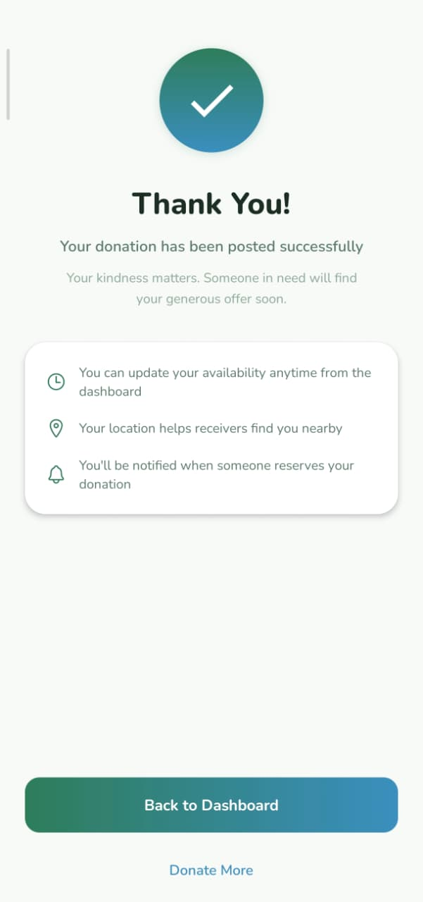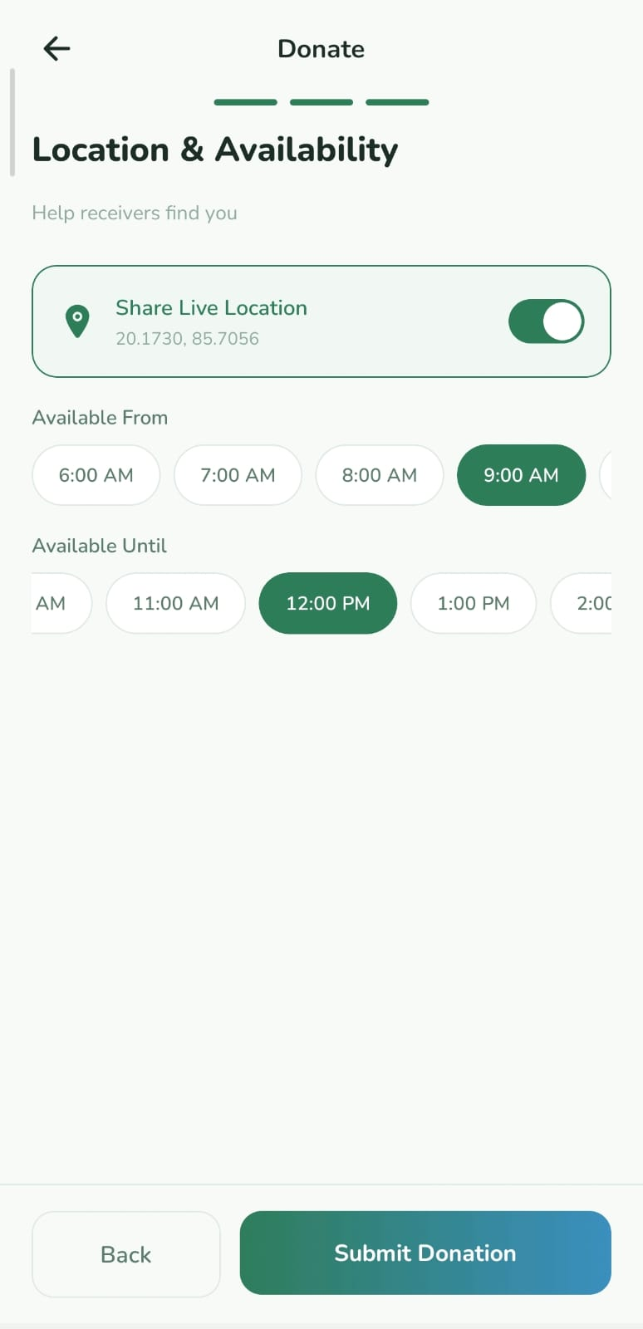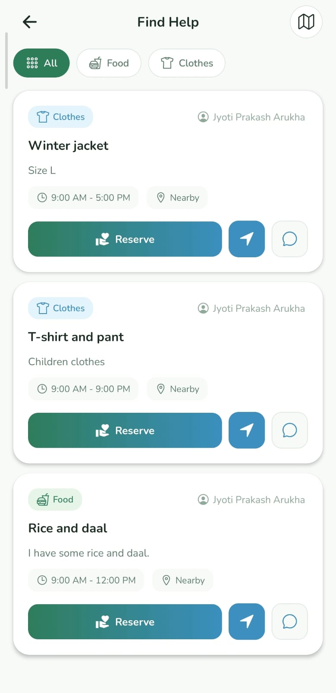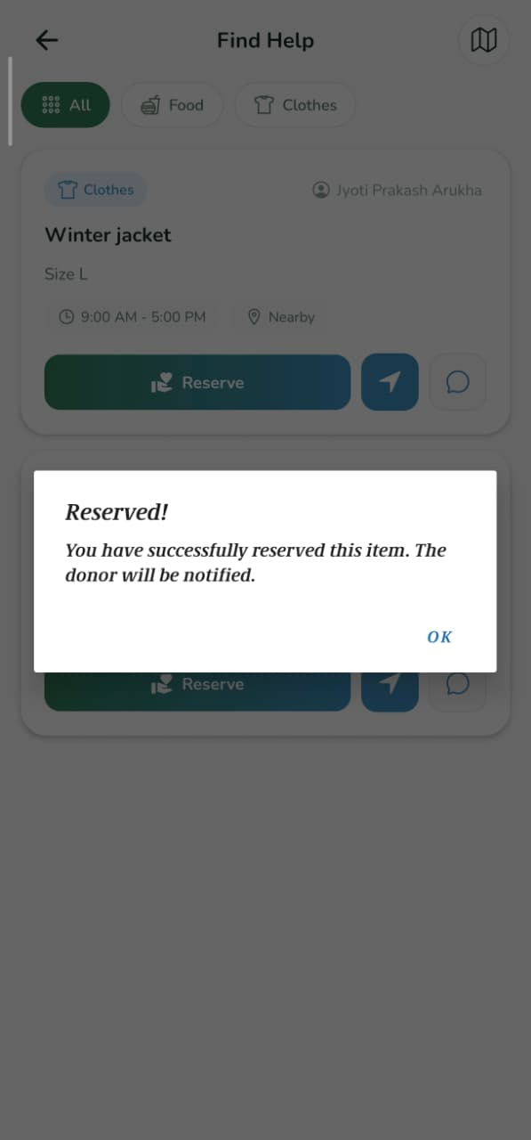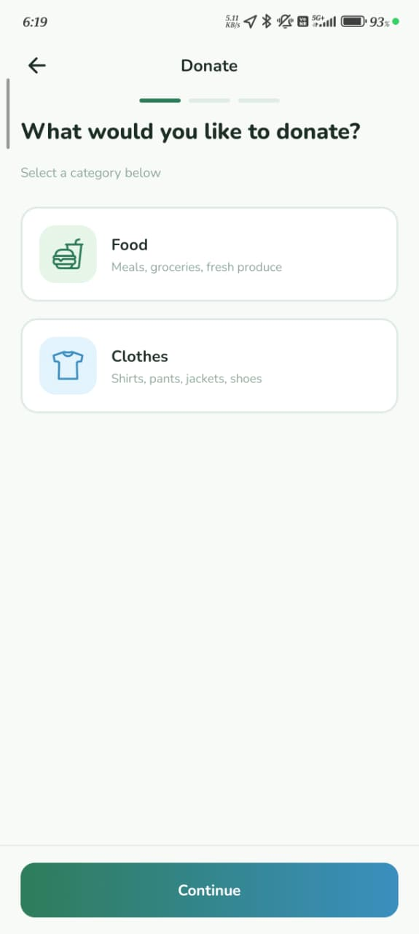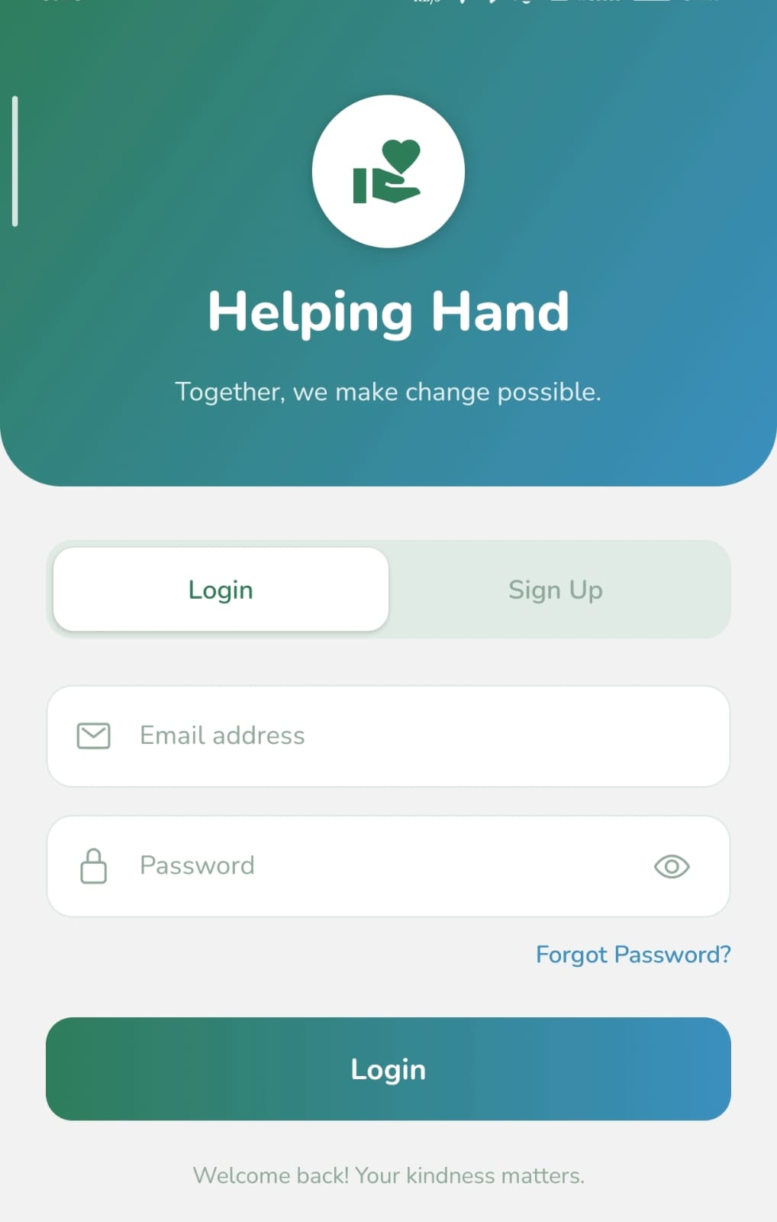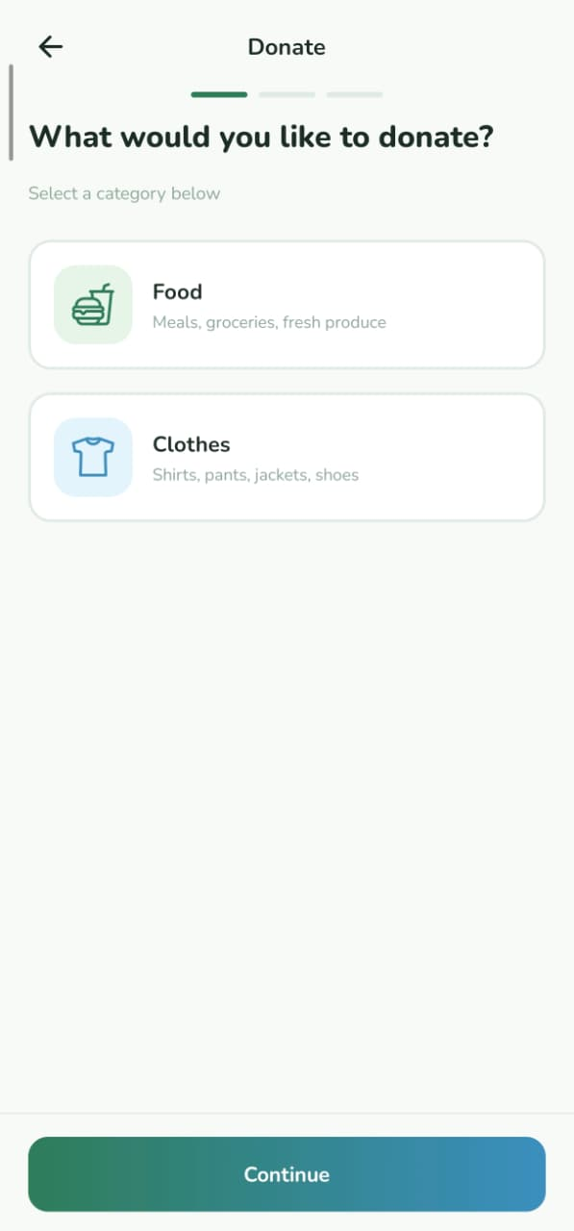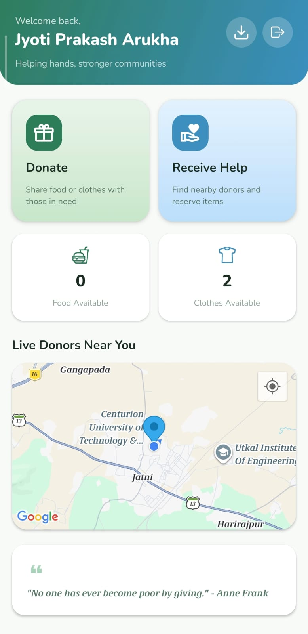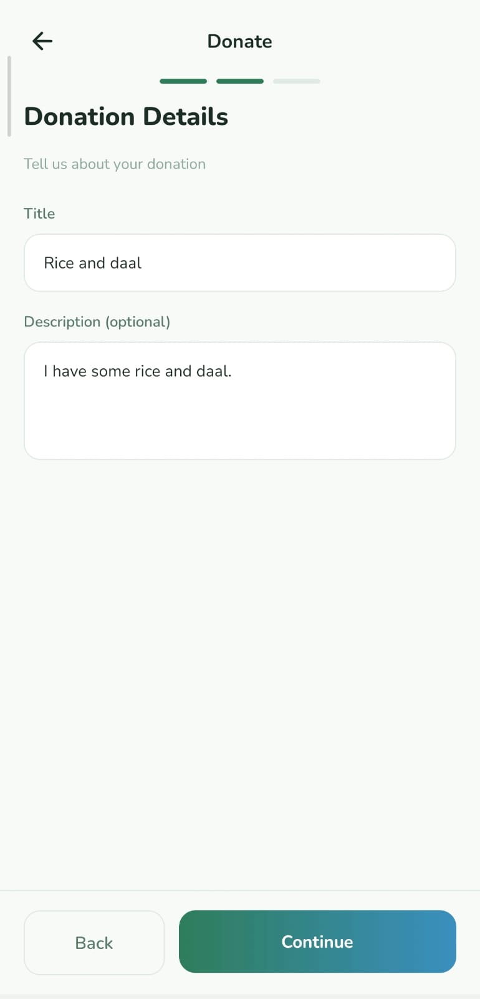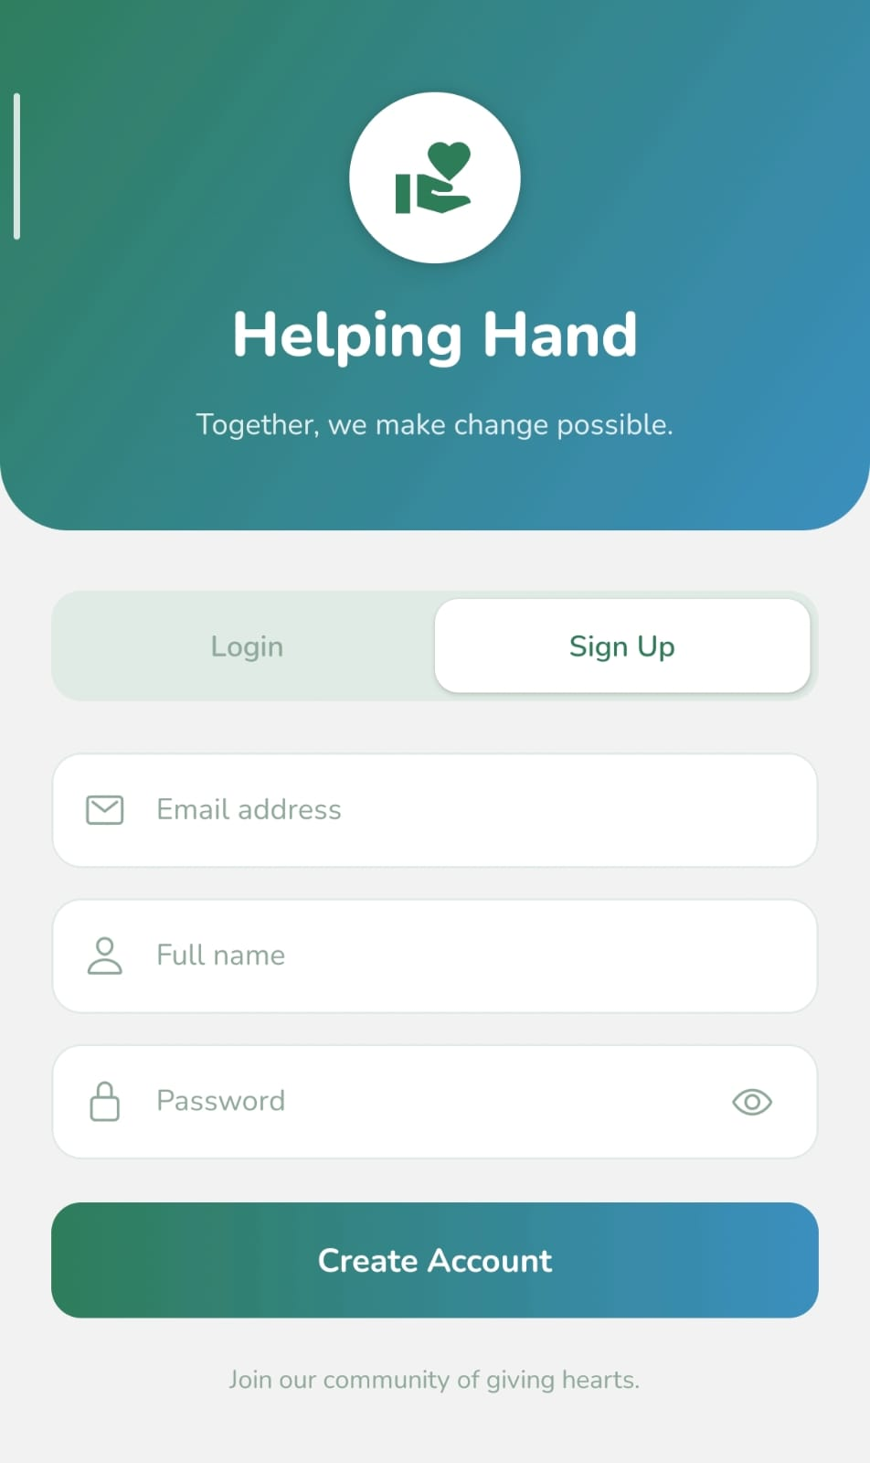

12. FUTURE SCOPE
The project can be enhanced by adding:
- Real-time chat between donor and receiver.
- Push notifications for reservation updates.
- Image uploads for donations.
- AI-based smart recommendation system.
- Rating and review system.
- Admin dashboard.
- Payment gateway integration for monetary donations.
- Multi-language support.
- Web version of the platform.

13. CONCLUSION
Helping Hand is a socially impactful and technically sound mobile application that connects generosity with need.
It provides:
- Real-time location-based donation system.
- Reservation mechanism to prevent conflicts.
- Secure authentication and database management.
- Clean and professional mobile interface.
- Scalable backend architecture.
The platform encourages kindness, reduces waste, and strengthens community bonds.
Helping Hand proves that technology can be used effectively to create meaningful social change.

14. REFERENCES
- React Native Documentation.
Available at: https://reactnative.dev/docs/getting-started
- Expo Documentation.
Available at: https://docs.expo.dev
- Node.js Official Documentation.
Available at: https://nodejs.org/en/docs
- Express.js Documentation.
Available at: https://expressjs.com
- PostgreSQL Documentation.
Available at: https://www.postgresql.org/docs/
- Drizzle ORM Documentation.
Available at: https://orm.drizzle.team
- Google Maps Platform Documentation.
Available at: https://developers.google.com/maps/documentation
- Zod Validation Library Documentation.
Available at: https://zod.dev
- bcrypt Documentation (Password Hashing).
Available at: https://www.npmjs.com/package/bcrypt
- REST API Design Best Practices.
Fielding, R. T. (2000). Architectural Styles and the Design of Network-based Software Architectures (Doctoral dissertation, University of California, Irvine).

